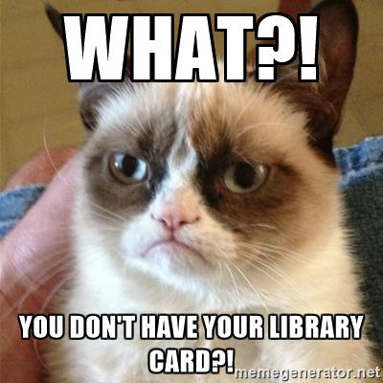

It’s important for you to have your library card so you can check out your materials at the

library. **Don’t miss out!**

So, how about this? Take a picture of your card on your phone **or** download either the *CardStar* or *KeyRing* app, and put your card on there.

The next time you come to the **Swampscott Public Library**, show Janina and she’ll enter your name for a drawing to win a gift certificate to Popo’s. She might also give you a little gift just for participating…

**Deadline for drawing will be July 5th, 2017**